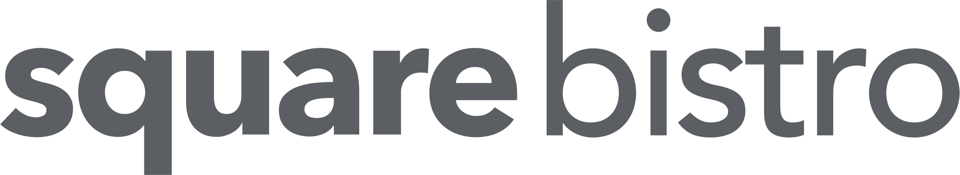

LUNCH
Snacks £5
Sourdough, tapenade, vinegar
Nacho, salsa, jalapeno, cheese, crème fraiche
Garlic focaccia
Crispy whitebait, spiced mayonnaise

Starters
Salt & chilli prawns, charred lettuce, satay £9
Rare beef fillet salad, celery, walnut, blue cheese, leaves £9
Mushrooms on toasted sourdough, veal jus, parmesan crisp £8.50
Smoked haddock fishcake, celeriac, apple £8.50

Mains
Beer battered haddock, mushy peas, tartare sauce, chips £11*
Thai chicken curry, rice, poppadoms £12* (naan bread £3.50)
Homemade burger, smoked cheese, bacon jam, brioche, mayo, fries £12*
Chicken fillet, bacon, chorizo, cheese, pitta, salad, coleslaw, criss cross fries £12
Salt & chilli chicken, Asian vegetable & noodle stirfry £11*
Club sandwich, chicken, bacon, cheese, curry mayo, salad & fries £10*
Smoked haddock, cabbage, mustard & langoustine cream, crispy egg, champ £15
Salt & chilli chicken Caesar salad £10*
Beef fillet strips, pepper sauce, pitta, rocket, melted cheddar & chips £13
Homemade chicken goujons, salad, garlic mayonnaise, chips £9.50*
Flat iron steak, red cabbage, chorizo, blue cheese sauce, chips, onion rings £20

Tortilla wraps
Salt & chilli chicken, chipotle mayo £8.25
Chicken goujon, barbeque, garlic mayo £8.25
Soup & ½ wrap £7.75
Soup & full wrap £9.50*

Sides £4
Chips. Crushed potato.
Tomato & red onion salad. Parmesan & truffle fries.
Potato dauphinois. Braised red cabbage & chorizo.
Champ. Seasonal vegetables.

2 Main Course £18
Selected main course only marked * Not available on Saturday’s or Bank Holidays

WE ARE PROUD TO USE LOCAL SUPPLIERS
Walter Ewing seafood, Peter Hannan meats, Alison Abernethy butter, Fred Murphy potatoes, Draynes farm, Cavanagh Eggs
Always inform server of any allergies

