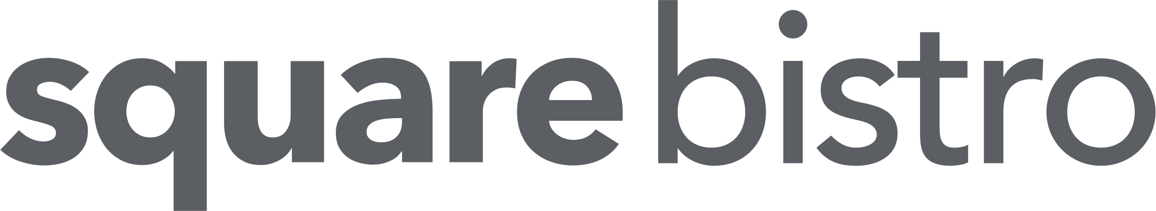

EARLY EVENING

Snacks £5
Sourdough, tapenade, vinegar
Nacho, salsa, jalapeno, cheese, crème fraiche
Garlic focaccia
Crispy whitebait, spiced mayonnaise

Starters
Salt & chilli prawns, charred lettuce, satay £9
Rare beef fillet salad, celery, walnut, blue cheese, leaves £9
Mushrooms on toasted sourdough, veal jus, parmesan crisp £8.50
Smoked haddock fishcake, celeriac, apple £8.50

Mains
Beer battered haddock, mushy peas, tartare sauce, chips £11
Thai chicken curry, rice, poppadums £12 (homemade naan bread £3.50)
Homemade burger, smoked cheese, bacon jam, brioche, mayo, fries £12
Smoked haddock, cabbage, langoustine & mustard cream, crispy egg, champ £15
Fillet steak strips stroganoff, rice, garlic bread £14
Chicken fillet, bacon, chorizo, cheese, pitta, salad, coleslaw, criss cross fries £12
Hake, leeks, charred baby leek, lemongrass veloute, crushed potato £19
Chicken fillet, serrano ham, asparagus, hazelnut & sage jus, champ £17
Duck fillet, roast cauliflower, confit mushroom, curry dressing, chilli potato £22
Smoked beef fillet, braised cheek, wild mushrooms, truffle jus, potato dauphinois £23
Flat iron steak, red cabbage, chorizo, blue cheese sauce, chips, onion rings £23
(can only be cooked medium or med-rare)
10oz salt aged sirloin, vegetables, onion rings, chips & pepper sauce £29.50

Sides £4
Chips. Crushed potato.
Tomato & red onion salad. Parmesan & truffle fries.
Potato dauphinois. Braised red cabbage & chorizo.
Champ. Seasonal vegetables.

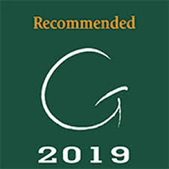
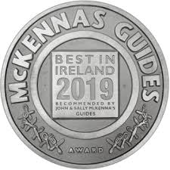

WE ARE PROUD TO USE LOCAL SUPPLIERS
Walter Ewing seafood, Peter Hannan meats, Alison Abernethy butter,
Fred Murphy potatoes, Draynes farm, Cavanagh Eggs
Always inform server of any allergies

